fps112

A fully 3D Doom clone

Competitive Analysis

Most 15-112 term project first person shooters I have seen have used raycasting. Raycasting is a compelling technique for this sort of project, but full 3D rendering allows for greater flexibility and verticality. The main gamemode for this project will be a randomly-generated maze of rooms, with enemies and an exit.

Structural Plan

The 3D components will be separated into their own file. Mesh objects, with a number of polygons, are drawn individually. They are currently given automatically generated hitboxes, but that may be changed if needed.

Algorithmic Plan

The most complex part of the project is of course the 3D components, and they are already done! It is difficult to explain the majority of it, but it is using traditional methods, with polygons having 3D coordinates and using linear algebra to project them into screen space. There is a clipping algorithm employed, backface culling, and very basic lighting. Also in this project, Kruskal’s algorithm is used to generate a maze.

Timeline Plan

I am slightly behind schedule on TP1, but the actual core gameplay should be at least partially implemented by then. I plan to have the entire core game done by TP2, but little issues have a way of popping up, as one would expect with the complexity of 3D. I am hoping to attempt to implement networked multiplayer with sockets between TP2 and TP3 if all goes to plan.

Version Control Plan

It’s on Github with the rest of my 15-112 work in a private repository. Look, see?

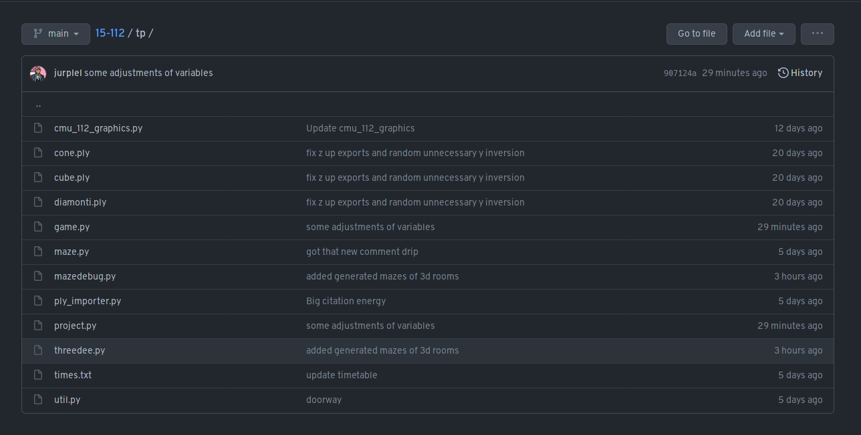

Module List

* NumPy
* Sockets/TCP possibly later